**LBPL Mini Project-1**

**Python game on Linux (Ubuntu) using Oracle Virtualbox**

**Name: Shreerang Mhatre**

**Roll no: 29**

**Batch: A2**

**PRN: 1032211745**

1. **Rock-Paper-Scissors Game**

In this mini project I have performed A Rock-Paper-Scissors game on Ubuntu. As we know about this game which we might have played in our childhood but now we are grownups so let’s play it using python programming.

This a very simple and easy to understand game. The opponent in this game is our computer we have to pick one choice and computer will randomly pick his choice, and after that the computer will check the rules and will give us the output.

**Rules of RPS Games are:**

* Rock wins against scissors.
* Scissors win against paper.
* Paper wins against rock.

The following are the screenshots of the program from start. This game is played in terminal in order to get the actual Linux UI

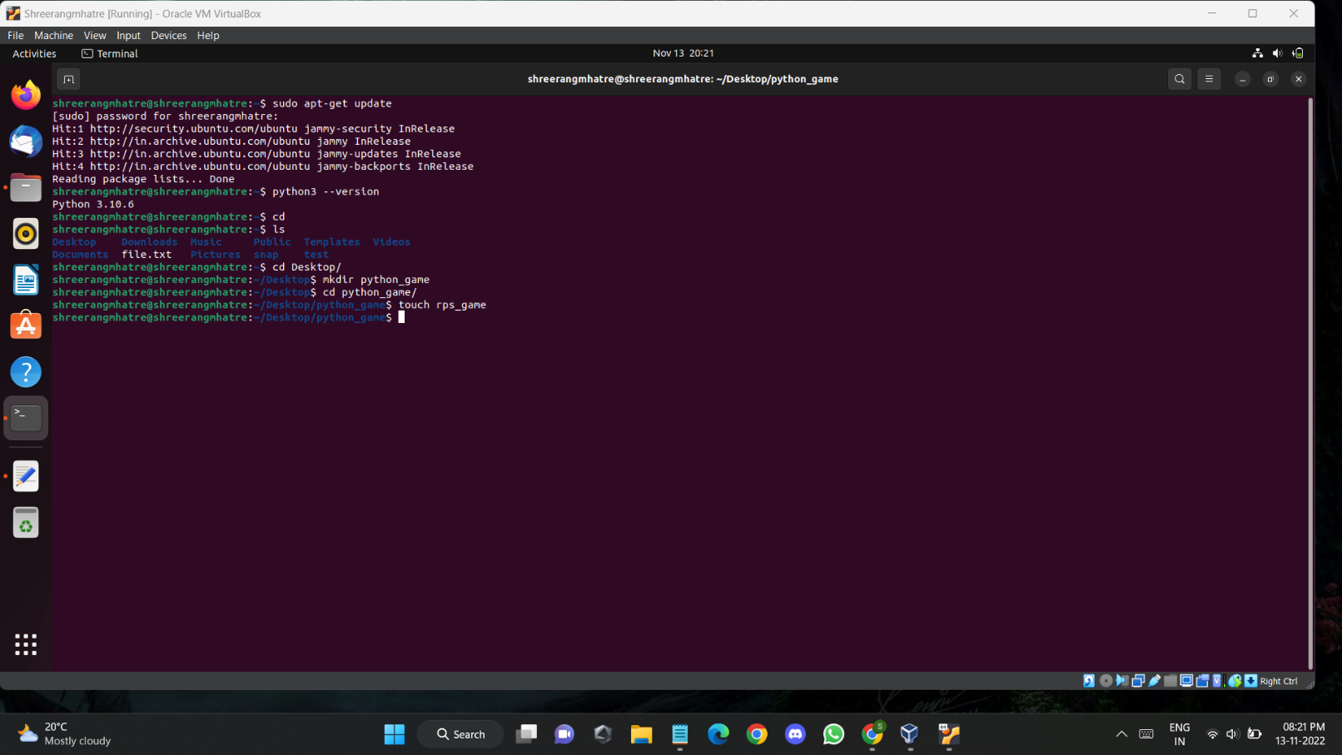**PROGRAM:**



